Storage Integration

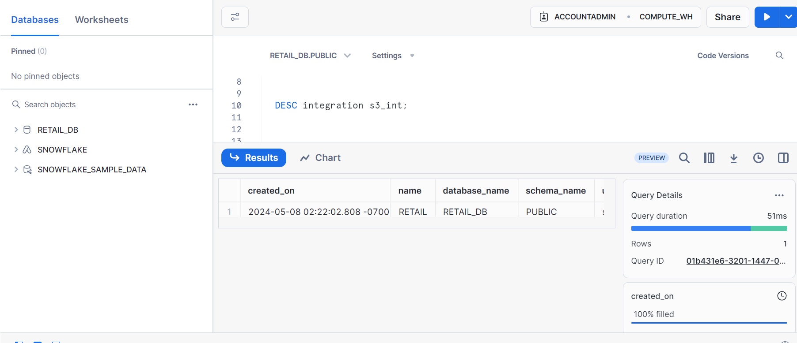

– Tables created in the snowflake

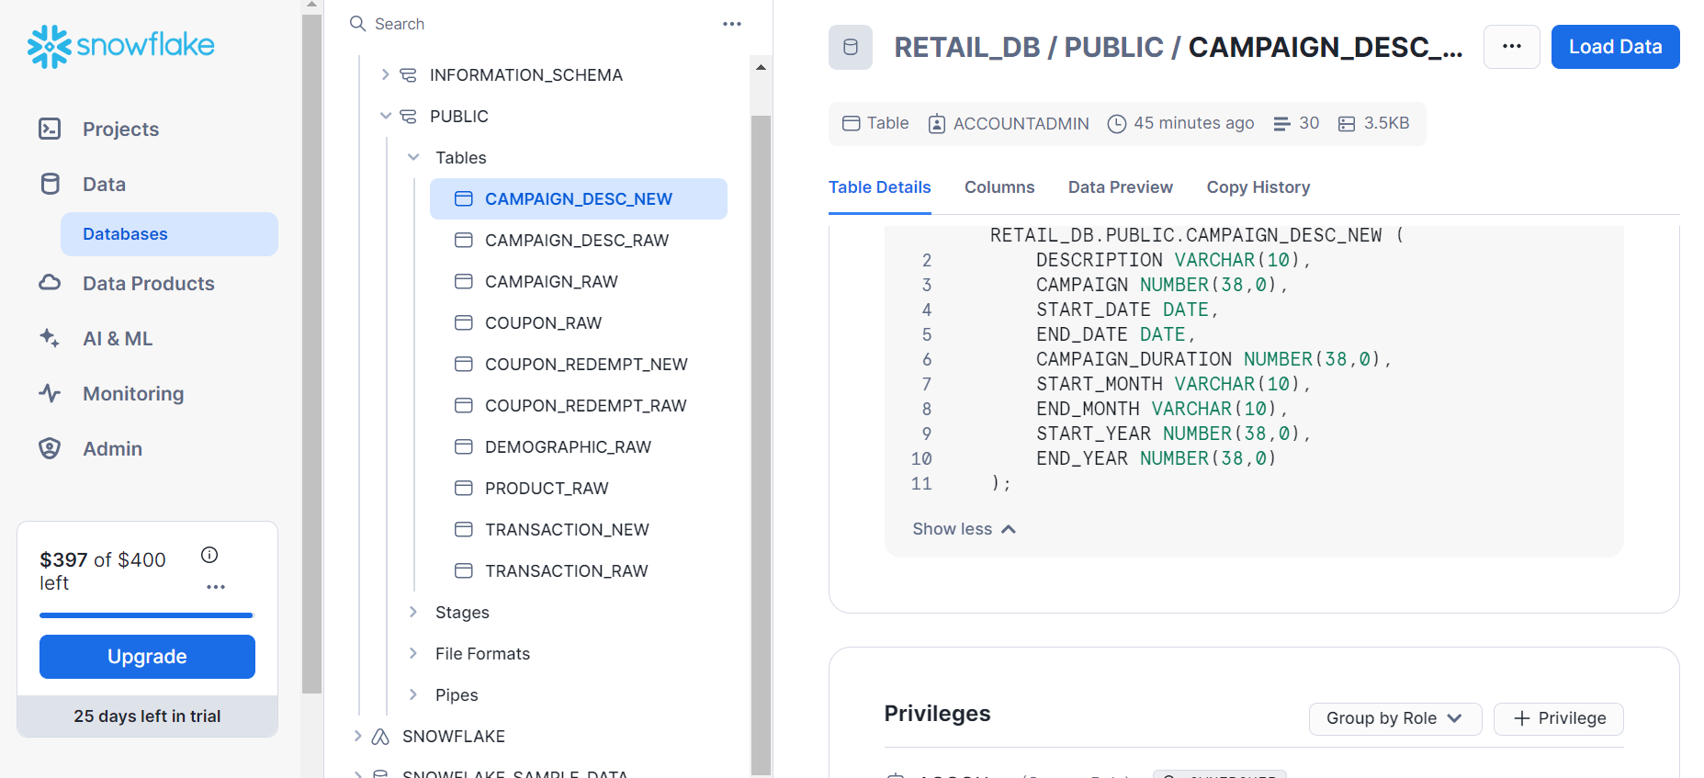

-- **Customer Demographics KPIs**

-- Count of Unique Households

SELECT COUNT(DISTINCT household_key) AS unique_households

FROM demographic_raw;

-- Household Composition Distribution

SELECT HH_COMP_DESC, COUNT(*) AS composition_count

FROM demographic_raw

GROUP BY HH_COMP_DESC;

--Age Distribution

SELECT AGE_DESC, COUNT(*) AS age_count

FROM demographic_raw

GROUP BY AGE_DESC;

-- Marital Status Distribution

SELECT MARITAL_STATUS_CODE, COUNT(*) AS marital_status_count

FROM demographic_raw

GROUP BY MARITAL_STATUS_CODE;

-- Income Distribution

SELECT INCOME_DESC, COUNT(*) AS income_count

FROM demographic_raw

GROUP BY INCOME_DESC;

-- Homeownership Distribution

SELECT HOMEOWNER_DESC, COUNT(*) AS homeownership_count

FROM demographic_raw

GROUP BY HOMEOWNER_DESC;

—----------------------------------------------------------------------------------------------------------

**Campaign KPIs**

--Number of Campaigns:

SELECT COUNT(*) AS total_campaigns

FROM CAMPAIGN_DESC_NEW;

--Campaign Duration

SELECT campaign,

start_date,

end_date,

ABS(DATEDIFF(DAY,end_date,start_date)) AS campaign_duration_days

FROM CAMPAIGN_DESC_NEW;

--Campaign Effectiveness

SELECT

c.CAMPAIGN,

d.DESCRIPTION,

d.START_DATE,

d.END_DATE,

COUNT(DISTINCT h.HOUSEHOLD_KEY) AS households_reached

FROM

CAMPAIGN_RAW c

JOIN

CAMPAIGN_DESC_NEW d ON c.CAMPAIGN= d.CAMPAIGN

JOIN

DEMOGRAPHIC_RAW h ON c.HOUSEHOLD_KEY = h.HOUSEHOLD_KEY

GROUP BY

c.CAMPAIGN, d.DESCRIPTION, d.START_DATE, d.END_DATE;

—------

**Coupon KPIs**

Coupon Redemption Rate

SELECT

(COUNT(DISTINCT COUPON_UPC) / (SELECT COUNT(DISTINCT COUPON_UPC) FROM COUPON_RAW)) * 100 AS redemption_rate

FROM COUPON_REDEMPT_NEW;

-- Coupon Usage by Campaign

SELECT

c.CAMPAIGN,

COUNT(cr.COUPON_UPC) AS coupon_redemptions

FROM

COUPON_RAW c

JOIN

coupon_redempt_new cr ON c.CAMPAIGN = cr.CAMPAIGN

GROUP BY

c.CAMPAIGN;

Product KPIs

Sales Value:

SELECT

product_id,

SUM(sales_value

) AS total_sales_value

FROM transaction_new

GROUP BY product_id

ORDER BY total_sales_value DESC;

– Manufacturer Distribution

SELECT

manufacturer,

COUNT(*) AS product_count

FROM product_raw

GROUP BY manufacturer

ORDER BY product_count DESC;

-- Department-wise Sales

SELECT

p.department,

SUM(td.sales_value) AS department_sales

FROM product_raw p

JOIN transaction_new td ON p.product_id = td.product_id

GROUP BY p.department

ORDER BY department_sales DESC;

-- Brand-wise Sales

SELECT

p.brand,

SUM(td.sales_value) AS brand_sales

FROM product_raw p

JOIN transaction_new td ON p.product_id = td.product_id

GROUP BY p.brand

ORDER BY brand_sales DESC;

—--------------------